Membership Type

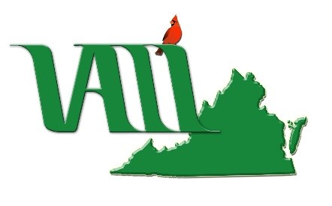 | VIRGINIA ASSOCIATION OF LAW LIBRARIES  Membership Application &  VALL Directory Update  June 1, 2022 - May 31, 2023

Individual……………………………….………………………$20.00  Extends to any resident of Virginia or its vicinity connected with a law library or library other than a law library or working as a consulting law librarian, and follows the person if he/she changes libraries. | Associate…………………..…………………………$25.00  A person not directly connected with a law library or other library, located in Virginia or its vicinity, may become an associate member, with approval of the Executive Board.
Institutional....………..………$20.00/designated staff person  Extends to a library or firm, located in the state of Virginia or its vicinity. Membership lies with the institution rather than the person; therefore, designated members may change as staff changes. Complete one copy of this page for each designated member. | Sustaining……………………………………………$50.00  Any company or institution supporting the goals of the Association may become a sustaining member with the approval of the Executive Board.  Student....……...………………………………………$7.50  An individual enrolled either in a library or law school.

Professional Information
Name:
Job title:
Place of Employment:
Directory Address:
Work Phone:
Mobile Phone:
Fax:
Home (Optional):
E-mail:
Other Memberships: | AALL SEAALL VLA SLA ALA Other (please specify)

Renew or Join at https://www.valawlibraries.org/ or Mail Check, Payable to VALL, and This Form To:

Please make checks payable to VALL and submit to VALL Treasurer Victoria Levy, State Law Library, Supreme Court of Virginia, 100 N. 9th St., Richmond, VA 23219

